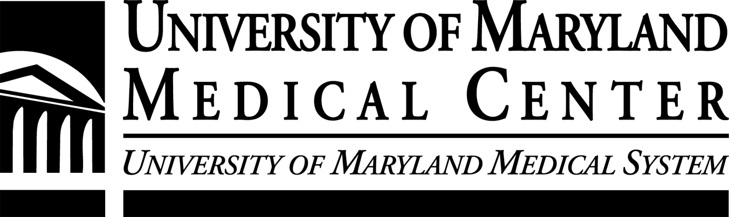
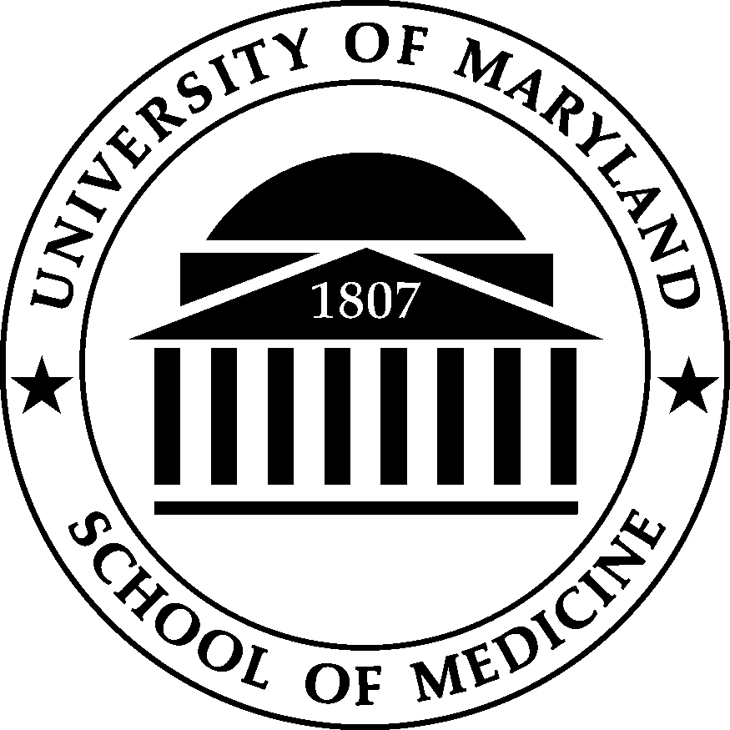

University of Maryland School of Medicine
Clinical Trials Advertising Policy

All faculty research must be conducted within the jurisdiction of the University of Maryland School of Medicine.

What is the purpose of this document?

Our goal is to make it as easy and cost-effective as possible for you, the investigator, to recruit the subjects you need to conduct your clinical trials.

This document provides the steps to follow to purchase advertising to support clinical trial patient recruitment. Because advertising on television is expensive and radio ads often don’t generate the response that newspaper ads do, most of our marketing efforts for clinical trials advertising are focused on local print media.

We can obtain better rates when we buy print ad space on the same newspaper advertising contract as the University of Maryland Medical Center (volume discounts apply by combining the hospital’s ads and our clinical trials recruitment ads).

Why should our ads all look the same?

One of the goals of the public affairs and marketing offices is to develop and maintain a strong, memorable identity for our organizations. We attempt, through advertising and other vehicles, to “bundle” perceptions into a single concept that is recognizable to the public. One of those concepts is that University of Maryland School of Medicine and the University of Maryland Medical Center (UMMC) are leading the way in Maryland and the nation in innovative, state-of-the-art medical advances and clinical trials. In addition, when all of our clinical trials ads look the same, the ads will become much more recognizable to the public. When the public sees our clinical trial advertisement, they will instantly recognize it as a credible University of Maryland ad.

What are IRB requirements for placing ads?

Institutional Review Board (IRB) approval is required before any clinical trial recruitment advertisement can be placed.

Because recruitment materials for investigational agents are viewed by the U.S. Food and Drug Administration as the very first part of the informed consent process, these materials must be in keeping with informed consent principles. Advertisements must present a balanced picture of what the research entails and must not overstate direct benefits to volunteers.

In general, this means:
- If the materials discuss possible benefits of study participation, then the information must be balanced by listing some of the risks.
- The materials should not overstate benefits because, in general, the research is usually being conducted to determine whether an intervention is in fact effective.
- The materials can mention that compensation will be provided, but excessive amounts of compensation, i.e. $100 - $700 can not be listed in the materials because such amounts of money are thought to place undue influence on a potential volunteer to participate.
- When compensation is mentioned in recruitment materials, it should state that the payment is being provided to research volunteers for their time during the study.
- Recruitment materials directed at volunteers and not referring medical personnel should be in a language understandable to them, i.e. lay terms.

I have IRB approval; what do I do now?

Once you have the IRB stamp of approval on your ad copy, call the UMMC marketing department at 8-7110. A marketing specialist will place your approved copy into the template (see below) and will discuss with you an appropriate placement schedule to fit your budget, including newspapers to reach your intended audience, what size ad is most appropriate, and how many times and for how long the ad should run.

What do the ads look like?

Do you have elevated triglyceride levels?

If you are at least 18 years of age, healthy, and have elevated triglyceride levels, you are invited to join a research study examining the effectiveness of a new investigational medication. Volunteers will receive free physicians visits, diet counseling, exams and payment for your time and effort.

For more information, please call the University of Maryland
School of Medicine Division of Cardiology at 410-328-6175.

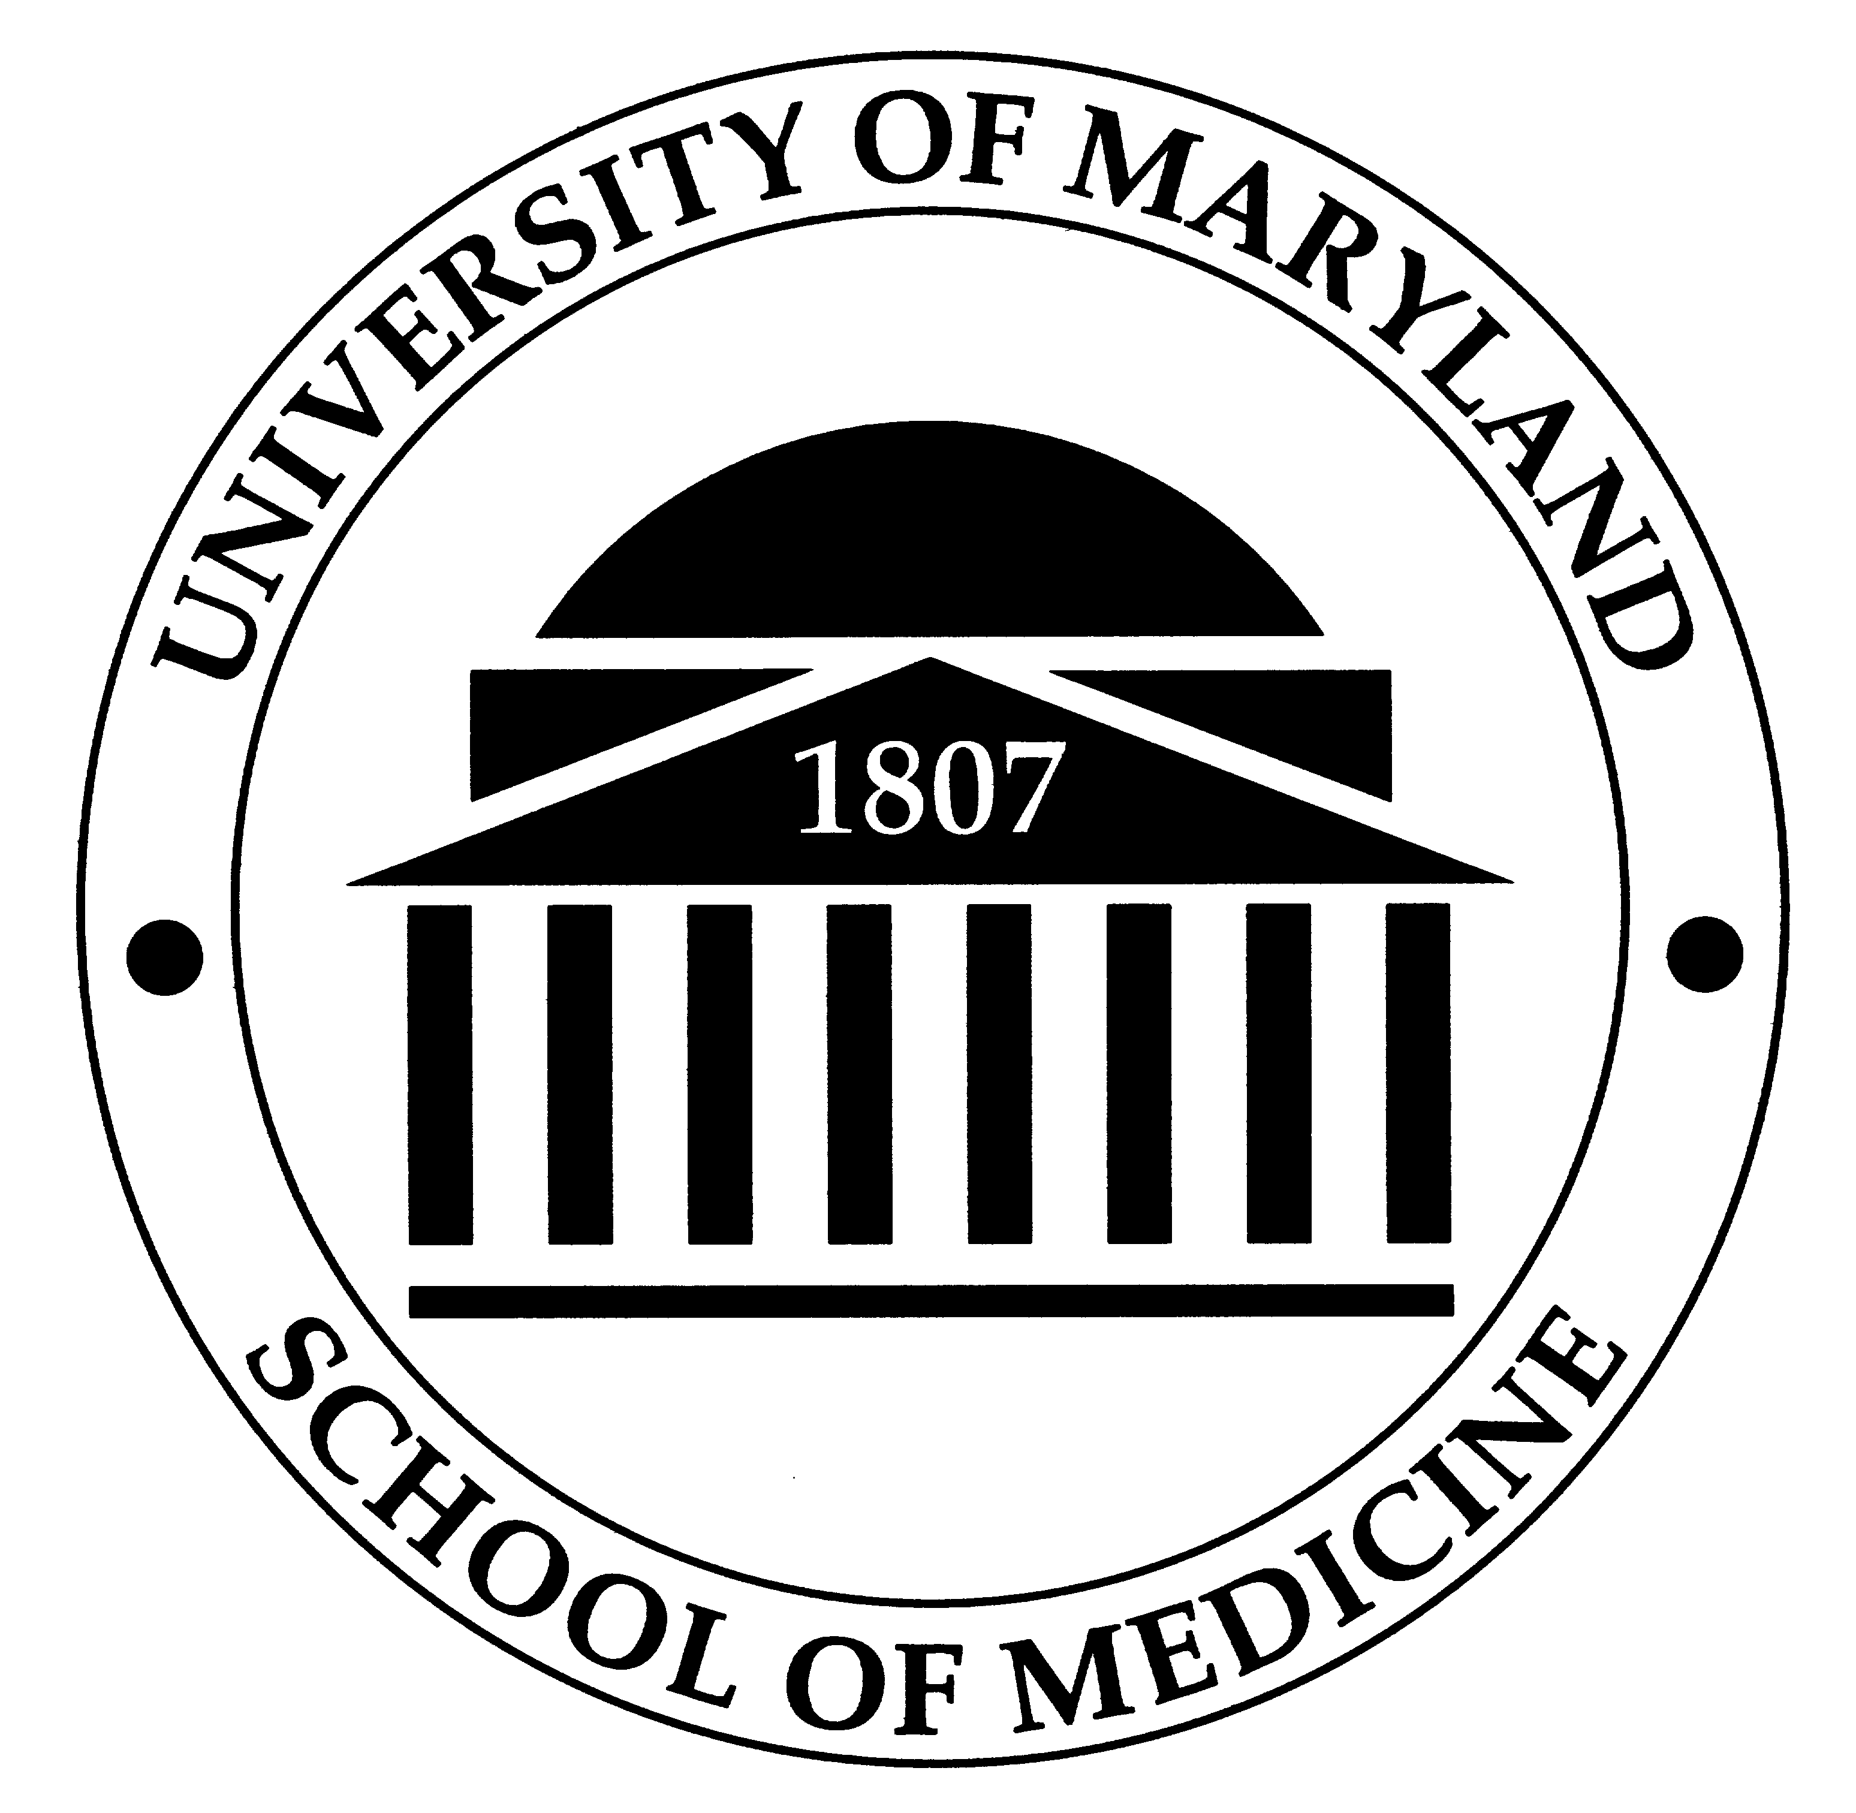

Michael Miller, MD, Principal Investigator

How much does an ad cost?

We are able to take advantage of the UMMC contract discounts with daily and other local newspapers. The contract discount allows you to save as much as 20-30 percent on every clinical trial ad placed.

You will be billed directly by the newspaper for the cost of the media for any ads you place. The UMMC marketing department consultative and design services are provided at no charge.
What if I want to do a radio ad?

Radio ads also need IRB approval. The copy that will be read in a radio ad will be exactly the same as (or very similar to) the copy in the print ad. Once you have IRB approval, please call the UMMC marketing department. (8-7110). Someone there will discuss with you your target audience and determine which radio station(s) best fit your audience, and can provide price quotes on different length ads (e.g., 15, 30 or 60 seconds).

What are the standards for flyers?

Flyers also need IRB approval. The copy used in a print and/or radio ad can also be used on a flyer. The difference between a flyer and a print ad is that you can be as creative as you like. There is no template for flyers as they are used within the UMB campus community and branding is not an issue.

Questions?

Contact Jennifer Litchman, Assistant Dean for Public Affairs at the School of Medicine at 6-8519 or Dave Brond, Vice President of Marketing and Planning at UMMC at 8-7110.

This document is a joint effort of the University of Maryland School of Medicine Office of Public Affairs and the University of Maryland Medical Center Department of Marketing and Planning.

Rev. 1/08

